Can Şentürk

Project Report for ECE 748 - Convolutional Neural Networks for Visual Recognition

Lecturer: Dr. Shahram Taheri

Contents

Part I 2

Part II 4

Part III 5

Results 5

Conclusion 5

# Part I

In this part first I designed a Convolutional Neural Network model with Tensorflow and Keras at Python. Then I choosed 2 numbers each for 3 hyperparameters on my model. These Hyperparameters are, Layer number, batch size, optimizer type. The model initially has 3 convulutional layers, batch size 32 and Adam optimizer.

Model 1 is the initial model

Model 2 has 2 convulutional layers

Model 3 has the batch size of 16

Model 4 has SGD as the optimizer

Figure of the models:

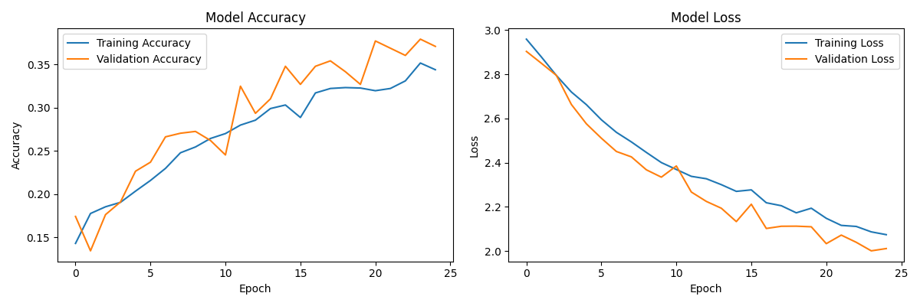 Fig.1 : Accuracy and Loss plots of the initial model.

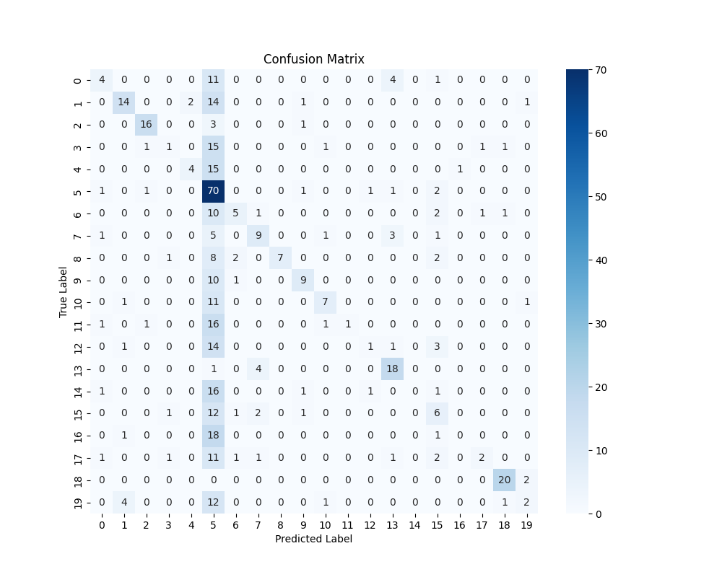

Fig. 2 Confusion matrix of the initial modal

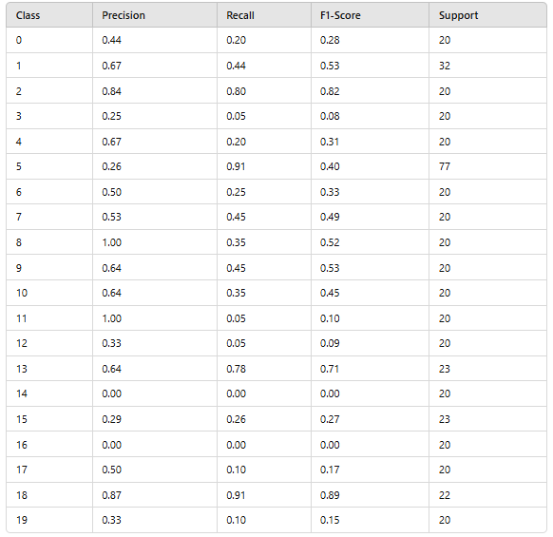

Fig. 3 statistics for each classes

Weighted Average Metrics on the best modal:

Precision: 0.4931

Recall: 0.4109

F1-score: 0.3691

Tables of the models:

|  |  |
| --- | --- |
| Model Numbers | Overall Accuracy |
| Model 1 (Initial) | 0.4109 |
| Modal 2 (2 layers) | 0.3795 |
| Modal 3 (SGD optimizer) | 0.2411 |
| Modal 4 (Batch size 16) | 0.4004 |

Table 1: Accuracies of the models.

Results & Conculusions: For this model the best hyperparamters are 3 convulutional layers, batch size 32 and Adam optimizer. And there is a big drop on the accuracy with the Stochastic Gradient Descent optimizer.

# Part II

|  |  |  |  |  |  |
| --- | --- | --- | --- | --- | --- |
|  | Accuracy | Epoch time avg. | Precision | Recall | F1-Score |
| VGG 16 | 0.8784 | 120 seconds | ≈ 0.879 | ≈ 0.879 | ≈ 0.879 |
| EfficientNetB0 | 0.9581 | 43 seconds | 0.9617 | 0.9581 | 0.9580 |
| Resnet50 | 0.9266 | 141 seconds |  |  |  |
| Inception v3 | 0.9371 | 41 seconds | 0.9400 | 0.9371 | 0.9359 |
| MobileNet | 0.9371 | 18 seconds | 0.9379 | 0.9371 | 0.9353 |

Table 2: Showing the evaluation metrices of transfer learning models.

Results & Conculusions: EfficientNetB0 gave the best results on accuracy. Also Mobilenet has good results evan though it is much more faster. The results shows it is possiable that for 25 epochs faster models which has fewer paramteres can give better results on image recognition.

# Part III

In this part the performance CNN will be used for feature descriptor. I will use the three good CNN modals at the previous parts. They are MobileNet, EfficientNetB0, ResNet50. And I will test them at first layers, middle layers, last layers in this order.

|  |  |  |  |  |
| --- | --- | --- | --- | --- |
|  | Accuracy | Percision | Recall | F1-Score |
| MobileNet 1 | 0.1761 | 0.1432 | 0.1761 | 0.1054 |
| MobileNet 2 | 0.2977 | 0.3579 | 0.2977 | 0.2306 |
| MobileNet 3 | 0.9455 | 0.9484 | 0.9455 | 0.9450 |
| EfficientNetB0 1 | 0.2537 | 0.2647 | 0.2537 | 0.1973 |
| EfficientNetB0 2 | 0.2872 | 0.2471 | 0.2872 | 0.2092 |
| EfficientNetB0 3 | 0.9665 | 0.9682 | 0.9665 | 0.9665 |
| ResNet50 1 | 0.1950 | 0.0892 | 0.1950 | 0.0909 |
| ResNet50 2 | 0.3249 | 0.3464 | 0.3249 | 0.2586 |
| ResNet50 3 | 0.9563 | 0.9577 | 0.9563 | 0.9559 |

Table3: Comparing the results of Layer choose.

Results & Conculusions: Later the feature descriptor used better the results been on this part.

# Results

The best results achived when transfer learning used. Transfer Learning had a huge impact on accuracy. Initiating the transfer learning at first layers didn’t seem to be a good approach. However using it at an earlier layer from the very last layer proved to be a better performer.

Models have a bias towards the class 5 DogHead. The Reason is every class have almost 100 images but the dog class has nearly 500 images which causes this bias. This situation is especially causing high error at simple models without the transfer learning.

# Conclusion

Overall best model is EfficientNetB0 a version of EfficientNet v1. Originally it is for classifying different kinds of food. It is very good for accuracy and speed.

Transfer Learning can increase the accuracy significantly without taking much more time then a normal CNN modal.